Circles for Reconciliation:
From ignorance to mutual respect and understanding

Conceived in 2016 in the wake of the Truth and Reconciliation Commission of Canada's report, Reconciliation Circles have already enabled more than 3,000 Aboriginal and non-Aboriginal people to get to know each other and better understand the realities of Aboriginal peoples, as well as develop the mutual respect and understanding needed to build a better Canada.
Raymond Currie, Ingrid Dowan and Father François Paradis, omi, explain.

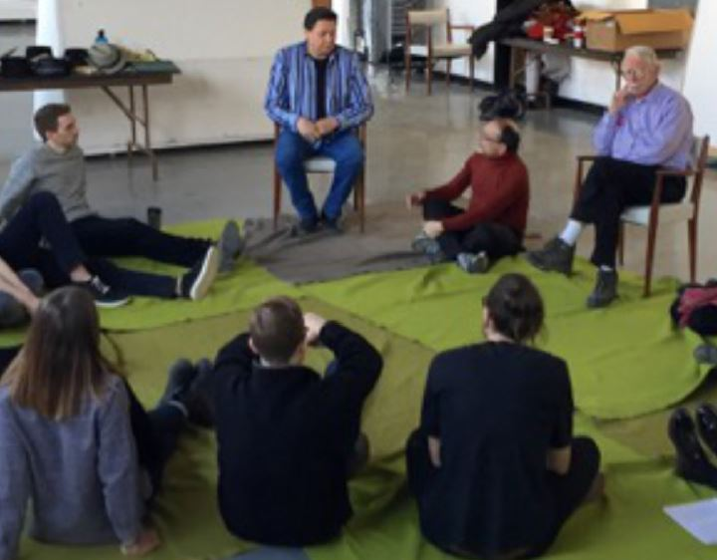
Photo Credit: Circles For Reconciliation.

It all started in 2015 when Raymond Currie, the coordinator of the Circles For Reconciliation project, read the report of the Truth and Reconciliation Commission of Canada: "I was reading this document with great interest, as my adopted son is Indigenous and my adopted daughter is Métis. At the very end of the report, I saw in bold print that anyone interested in implementing the Commission's recommendations was invited to take action. I immediately started thinking."
Raymond Currie quickly mobilized with Elders and leaders from different Indigenous communities. Nine months later, Circles For Reconciliation was founded.
Raymond Currie elaborates: "At its core, our idea is very simple, yet elegant in that very simplicity. We invite a dozen or so Indigenous and non-Indigenous people to meet, ten times, to discuss a variety of topics affecting the lives, past, present and future of Indigenous people and Canadians. All in an atmosphere of equality and respect.
"Each circle has two facilitators, one Indigenous and one non-Indigenous. The circle is made up of five non-Indigenous participants and five Indigenous participants. Everyone has a chance to speak and contribute, through the use of an Indigenous talking stick. Over the course of ten meetings, participants have a chance to learn more about each other, not to mention their relationships. And at the end of the tenth meeting, we invite everyone to further activities to encourage continued engagement.”
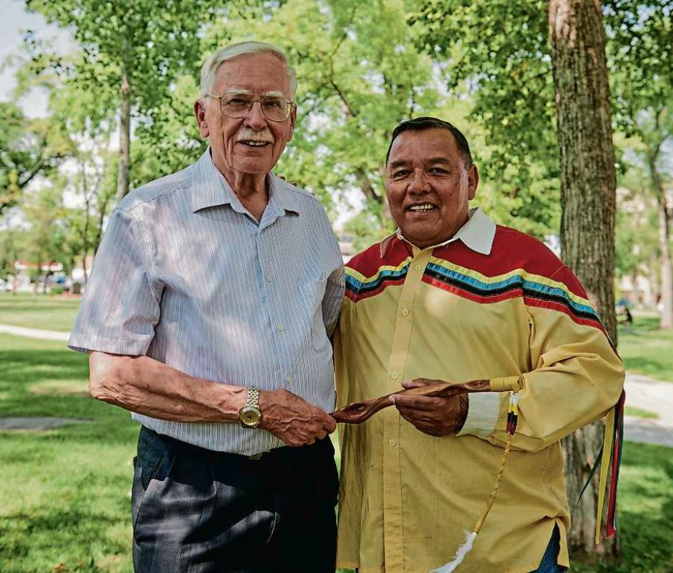
Raymond Currie and Clayton Sandy, Indigenous ambassador of Circles For Reconciliation, with and Indigenous talking stick.
Photo Credit: Winnipeg Foundation
As a result, since the inception of Circles For Reconciliation, more than 3,000 Canadians have been able to meet face-to-face. And 39 organizations, churches, social agencies and community groups are preparing to participate in about 60 new Circles for Reconciliation. There have been circles in Manitoba, but also in Alberta, British Columbia, Ontario and Saskatchewan. And the organization has opened an office in Toronto.
“The feedback is overwhelmingly positive," says Currie. We interview past participants six months after their last meeting to get their feedback. Over 90% of them would recommend the Circles to other Canadians. That's very encouraging.”
Ingrid Dowan, Event Coordinator and Indigenous Recruitment Officer, agrees. "I came to work for Circles For Reconciliation because Circles has helped me to better understand myself and non-Indigenous people. I am from the Dakota Sioux Valley First Nation. My parents both went to residential schools. My mother said she was kidnapped in 1949, as government agents came in a Cessna plane to take her. She did not see her parents for several years. The experience was traumatic. And it was not until much later that she dared to talk about it with our family.”
"What is very positive, despite such stories, is that a large majority of non-Indigenous people want reconciliation. They want to learn more about Indigenous realities. They want to understand what we've been through, and what our challenges are now. And how they can build a better country. Including new Canadians. What comes out of this is that the participants get rid of the stereotypical images they have of ‘Indians’ or ‘whites’. They come to respect each other. It takes time, but the more you learn, the more you are in dialogue with others, the more you come to know and understand each other."
En français, s.v.p.
In particular, Dowan encourages the faithful of the Archdiocese of St. Boniface to participate in the Circles For Reconciliation. "A group from Mary, Mother of the Church parish participated. But Mary, Mother of the Church is pretty much at the forefront of the diocese. So far, it is the United, Mennonite and Lutheran churches that are participating.
Father François Paradis, omi, a trainer in the Returning to Spirit program, sees it the same way. "I have spent almost 17 years ministering to Indigenous communities in the Fort Alexander and Hollow Water area. I have seen firsthand how much the indigenous people have suffered. Often when I spoke to the youth in Ojibway, they would respond in English. They did not understand the language of their parents and grandparents.”
"Yet language is intimately linked to identity, culture and spirituality. It is the intimate link between the people and Mother Earth. For years, when celebrating Mass, I recited the second Eucharistic prayer in Ojibway. The effect was almost palpable. The language created a special sacred space within the Indigenous congregations.
"That is why I advocate, with the Our Lady of Guadalupe Circle (1), respect for language, which is one of the foundations of culture. Unfortunately, Canada has gone through a period of assimilation, arrogance and cultural superiority, which has profoundly damaged the transmission of Indigenous languages.
"French Canadians know this. We had to fight, even break the law, to teach French in Manitoba schools. That's why I encourage Francophones in the diocese to participate in initiatives like Returning to Spirit and Circles For Reconciliation."
Especially since French will soon have its place in Circles For Reconciliation. Raymond Currie explains: "We have just received a grant from Francofonds. And two professors from St. Boniface University have translated our programs so that we can hold reconciliation circles in French. We’ve had them since March, 2020."
To learn more about Circles For Reconciliation or to join a Circle, visit the Circles For Reconcilation website at www.circlesforreconciliation.ca
To download an English Circles For Reconciliation flyer, click here.
To download a French Circles For Reconciliation flyer, click here.

(1) The importance of Indigenous languages
A Canadian Catholic coalition of Aboriginal people, bishops, clergy, lay movements and institutes of consecrated life for women and men, the Our Lady of Guadalupe Circle seeks to renew and promote the relationship between the Catholic Church and Aboriginal peoples in Canada. Our Lady of Guadalupe Circle has issued a statement on the importance of Aboriginal languages. (Click here) This open letter affirms the importance of language in the revitalization of Indigenous cultures and expresses a commitment to finding ways to support this essential aspect of reconciliation. To view a promotional video, click here. Or visit the Our Lady of Guadalupe Circle website: https://www.ourladyofguadalupecircle.ca/

